COMMUNITY BUILDING TOOL

A project report submitted in partial fulfillment of the Requirements for the award of the degree of

BACHELOR OF SCIENCE IN COMPUTER SCIENCE
By

MUHAMMED NASIM (OSATBCA013)


DEPARTMENT OF COMPUTER SCIENCE
ORIENTAL SCHOOL OF HOTEL MANAGMENT,

LAKKIDI, WAYANAD,
APIL 2022

INDEX
CONTENTS PAGENO
- INTRODUCTION 7
- SYSTEM ANALYSIS 11
HardwareSpecification 11
SoftwareSpecification 11
FeasibilityStudy 12
TechnicalFeasibility 13
OperationalFeasibility 13
EconomicalFeasibility 14
Software RequirementSpecification 15
- SYSTEMDESIGN 17
Users oftheSystem 17
Modularity Criteria 17
InputDesign 17
OutputDesign 18
ModuleDescription 19
ArchitectureDiagram 20
Database Design 28
- SYSTEMDEVELOPMENT 32
About theFrontEnd 32
About theBackEnd 33

- SYSTEM TESTING 36
TypesofTesting 37
- SYSTEM IMPLEMENTATION 41
- SYSTEMMAINTANANCE 44
- SCREENSHORTS… 46



1.INTRODUCTION

Recruitment in the Tech Space is community driven, and making a career is much more than just sending a CV to get your next job – it’s all about personal branding.

While most IT professionals agree that keeping abreast with the latest in the tech world is a necessity, they also agree that they don’t have the time to keep scanning for the latest information across various disparate sources. This is where niche online communities play an important role.

Focused tech communities connect techies in the most interesting and focused ways. They have moved beyond just code submissions now. And are now crowd-sourced platforms for interacting with like-minded people, improving knowhow and sharpening skills to remain cutting edge.

Reasons to build an online community
- Interacting with like-focused people: The best part of being in an online community is that you get to interact and share with like-minded people with a shared focus. Arvind Singh, Director of Engineering, PayUBiz emphasizes the importance of being connected with peers pursuing the same tech focus. He says, “An online community allows a techie to brainstorm with his peers, while eliminating the barriers of time and geography. There are long threads of technology discussions that help a techie to upscale his knowledge. So, even if you are not able to contribute much in the community, you still have a lot to take away.”
- Get visible and get hired:This is the most lucrative reason for being associated with an online community. Tech communities not only enable members to upscale their technology skills, but also provide them high visibility among IT recruiters – giving them a unique opportunity to be identified and offered incredible careers and packages.
- Cutting-edge knowhow:Online tech communities today are not just about knowledge sharing today. They are abuzz with the latest developments in technology. Aloknath De, Corporate Vice President and Chief Technology Officer at Samsung India, asserts, “Being associated with an online community always brings a host of advantages. While one gets to brush up his technology skills, he is also updated about the latest developments in technology. People discuss the latest tech developments and opinions come from all levels, making the discussion more comprehensive.”
- Learn from Experts –Online communities also act as a bridge between the experts and learners. TechGig.com, for instance, associates with industry experts and tech top-shots, who share their expertise with community members through webinars.

About Existing System

There is no convenient tool for community building. Even though importance of
Community is known among colleges and other entities, the efficiency of
Handling members and other community activity is very low.
The statistics of the community members and community activity is not
Monitored in the existing system.

About Proposed System

The proposed system is a community website for users to visit and register for
Community membership, volunteering and to use other features provided by
The online website. Admins can view the registrants application, various
Statistics and manage what users see in the website.
The system mainly contains:
- Locally hosted website for users
- Locally hosted admin panel for admins

The new system will be efficient in handling community members and activity
Since everything is recorded in an online database.

This community tool will be used for handling TinkerHub community which exists in most of the colleges.

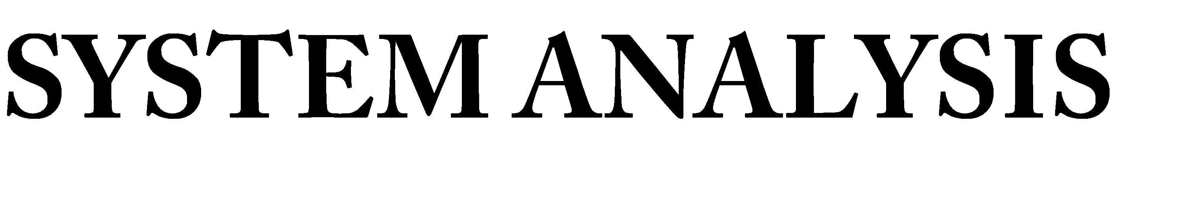

2.SYSTEMANALYSIS

HardwareSpecification
The selection of hardware is very important in the existence and proper working of any of the software. When selecting hardware, the size and capacity requirements are also important. The hardware must suit all application developments.
    - Processor : Core i3 or above.
    - SystemBus : 32Bit orabove
    - RAM : 2GB or above
    - HDD : 100 GB or above
    - Mobile : Supporting internet and javascript

SoftwareSpecification
One of the most difficult tasks is selecting software, once the system requirement is find out then we have to determine whether a particular software package fits for those system requirements. This section summarizes the application requirement.
    - OperatingSystem : Windows 7 or Above, Any 32 bit or aboveplatform
    - FrontEnd : Next js, redux, tailwind css, jsx
    - BackEnd :Supabase, firebase, postgreSQL
    - IDE : Visual studio code

FeasibilityStudy
A feasibility study is a preliminary study undertaken to determine and document a project's viability. The results of this study are used to make a decision whether to proceed with the project. If it indeed leads to a project being approved, it will - before the real work of the proposed project starts - be used to ascertain the likelihood of the project's success. It is an analysis of possible alternative solutions to a problem and a recommendation on the best alternative. It, for example, can decide whether an order processing be carried out by a new system more efficiently than the previous one. The feasibility study proposes one or more conceptual solutions to the problem set for the project. The conceptual solution gives an idea of what the new system will look like. They define what will be done on the computer and what will remain manual. It also indicates what input will be needed by the system and what outputs will be produced. These solutions should be proven feasible and a preferred solution is accepted.
The feasibility study environment enables all alternatives to be discussed and evaluated. This phase starts with an identification of the main characteristics of the required system. During this stage it is important to collect information as much as possible about the software package that might meet the specification from as many sources as possible.
Normally, the central endeavor of a feasibility study is a cost benefit analysis of various alternatives. It can be defined as a systematic comparison between the cost of carrying out a service or activity and the value of that service or activity. The main benefits are qualitative than quantitative.
A feasibility study could be used to test a new working system, which could be used because:

    - The current system may no longer suit itspurpose,
    - Technological advancement may have rendered the current systemobsolete,
    - The business is expanding, allowing it to cope with extra workload,
    - Customers are complaining about the speed and quality of work the business provides.
    - Competitors are now winning a big enough market share due to aneffective integration of a computerizedsystem.
When a new project is proposed, it normally goes through feasibility assessment. Feasibility study is carried out to determine whether the proposed system is possible to develop with available resources and what should be the cost consideration.

Facts considered in the feasibility analysis were

TechnicalFeasibility
    - Operational Feasibility
    - EconomicFeasibility

TechnicalFeasibility
This involves questions such as whether the technology needed for the system exists, how difficult it will be to build, and whether the firm has enough experience using that technology. The assessment is based on an outline design of system requirements in terms of Input, Output, Fields, Programs, and Procedures. This can be qualified in terms of volumes of data, trends, frequency of updating etc. in order to give an introduction to the technical system.
The system requires normal configuration computer system that are commonly available. The software requirements are C# .Net, Windows 8 or higher versions of OS. Thus proposed system is technically feasible.

OperationalFeasibility
This analysis involves how it will work when it is installed and the assessment of political and managerial environment in which it is implemented. People are inherently resistant to change and computers have been known to facilitate change. The new proposed system is very much useful to the users and there for it will accept broad audience.
The proposed system offers:

      - Greater userfriendliness
      - Better output which can be easilyinterpreted.
      - Higher speed.
      - Meets the requirements of theorganizations.

EconomicFeasibility
This involves questions such as whether the firm can afford to build the system, whether its benefits should substantially exceed its costs, and whether the project has higher priority and profits than ot0her projects that might use the same resources.
whether the project is in the condition to fulfill all the eligibility criteria and the responsibility of both sides in case there are two parties involved in performing any project.
This study presents tangible and intangible benefits from the project by comparing the developments and operational costs. The technique of cost benefit analysis is often used as a basis for assessing economic feasibility. This system needs some more initial investment than the existing system, but it can be justifiable that it will improve the quality of service.
Thus feasibility study should center along the following points:

      - Improvement resulting over the existing method in terms of accuracy,timeliness.
      - Cost comparison.
      - Estimate on the life expectancy of thehardware.
      - Overallobjective.

Software RequirementsSpecification
A software requirements specification (SRS) is a description of a software system to be developed, laying out functional and non-functional requirements. (Non-functional requirements impose constraints on the design or implementation such as performance engineering requirements, quality standards, or design constraints.) The specification may include a set of use cases that describe interactions the users will have with the software. The software requirements specification document enlists enough and necessary requirements that are required for the project development. To derive the requirements we need to have clear and thorough understanding of the products to be developed or being developed. This is achieved and refined with detailed and continuous communications with the project team and customer till the completion of the software.

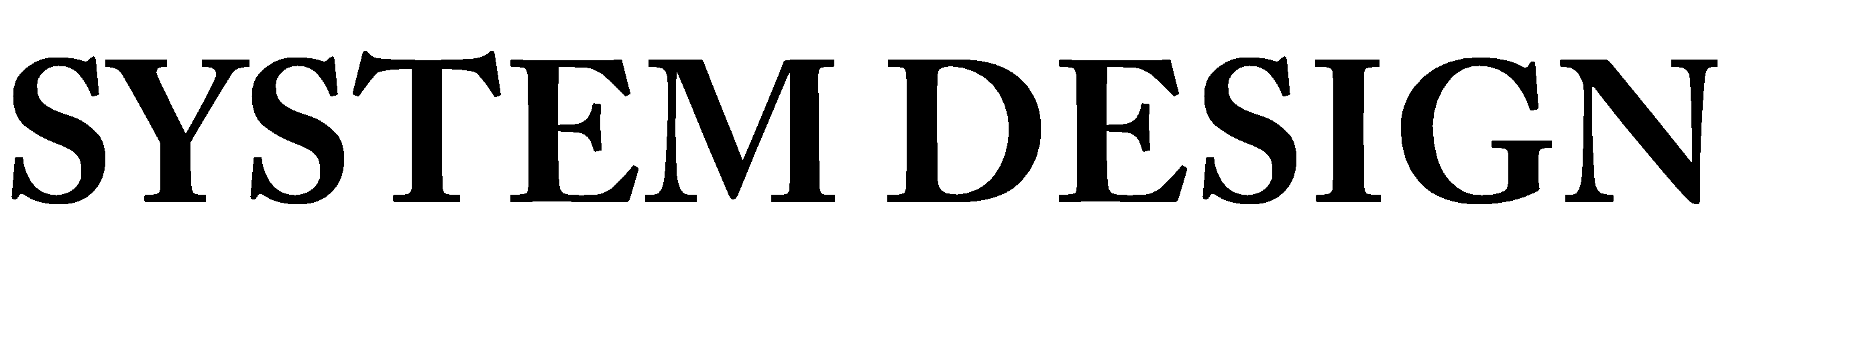

3.SYSTEMDESIGN
Design is the first step in the development phase for every engineered product or system. Computer software designing techniques like engineering design approaches in the other disciplines, changes continuously as new methods, better analysis and broader understanding evolve.
System design involves translating information requirements and conceptual design into technical specification and general flow of processing. After the user requirements are identified, related information is gathered to verify the problem and after evaluating the existing system, a new system is proposed. The proposed system consist of various tables, their maintenance and report generation.

Users of the system

Users can visit the website of the community and can perform various featuresProvided for the end user by the developer. Admin can access a private part of The website and login to their account and perform various features providedFor them. Root admin can login to the database and manage all records.

ModularityCriteria
ModuleDesign

Root Admin: Root admin can manage/create admins and other fields
Admin: Admin can view all the applications sumbited by the user
User:User can view the website and register for community membership,
Volunteering, counseling.

InputDesign
Input design is part of overall system design, which requires careful attention. The major objectives of input design are to make the data entry easier logical and error free. With this objective the screen for the system are developed. The input design requirement such as user friendliness, consistent formal and interactive dialog boxes for giving the right message and help for the user at the right time are also considered for the development of the project. The decisions made during the input design are:
- To provide cost effective method ofinput
- To achieve the highest possible level of accuracy
- To ensure that the input is understood by theuser
The input type involves converting the user-originated inputs into a computer-based format. The aim of the computer design is to make the data entry easier, logical error free. It helps us to filler errors in the input data that otherwise entered into the database might have brought in a lot of inconsistency.
Alert for wrong entries such as primary key duplication, letters in numeric data, wrong data format, range exceed have been provided in the application. Upon this, a well-documented instruction set has been provided for the non-frequent and first-time users to familiarize them with our web site.
Maximum care has been taken to ensure that users type in only minimum data into the system, as all he or she will have to do is to move and click the mouse or strike a key to select the desired data at the desired position.
The input design is the link between the information system and the user. It comprises developing specification and procedures for data preparation and those steps that are necessary to put input data into a usable form for processing data entry. Instructing the computer to read data from a written or a printed document can achieve the activity of putting data into the computer for processing or it can occur by having people key data directly into the system. The design of inputs focuses on controlling the amount of inputs required, controlling errors, avoiding delay, avoiding extra steps and keeping the process simple.

OutputDesign
Output design generally refers to the results and information that are generated by the system. For many end-users, output is the main reason for developing the system and the basis on which they evaluate the usefulness of application.
Theobjectiveofasystemfindsitsshapeintermsoftheoutput.Theanalysisoftheobjective of a system leads to determination of outputs. Outputs of a system can take various forms. The most common are reports, screens displays, printed form, graphical drawing etc. the output also vary in terms of their contents, frequency, timing and format. The users of the output, its purpose and sequence of details to be printed are all considered. The output from a system is the justification for its existence. If the outputs are inadequate in any way, the system itself isinadequate.
Output design phase of the system is concerned with the convergence of information to the end user-friendly manner. The output design should be efficient, intelligible so that system relationship with the end user is improved and their by enhancing the process of decision-making.
Output Types:

- External Outputs, whose destination is outside the organization and is the main image of theorganization.
- Internal Outputs, whose destination is within the organization and which requirecareful
designbecauseit is user’s main interface with thecomputer.

- Operational Outputs, whose use is purely within the computerdepartments.
- Interactive outputs, which involve the user in communicating directly with thecomputer.

Module Description

DB ADMIN
- Add admin: Db admin can add admin with login credentials
- Delete admin:Db admin can delete admin
- Modify admin:Db admin can change or reset admin login credentials

ADMIN
- View members: Admin can view users community registration applications
- View volunteers: Admin can view volunteer applications
- View Schedules: Admin can view counseling schedules

USERS
- View community site: Users can visit the website and see latest updates
- Register as member: Users can register to community
- Register as volunteer: Users can register for volunteering community
- Register for counseling: Users can register for counseling schedule

Architecture Diagrams

Data Flow Diagrams:
A data flow diagram (DFD) or a bubble chart is a graphical tool for structured analysis. DFD models a system by using external entities from which data flow to a process, which transforms the data and creates output data flows which go other process or external entities or files. Data in files may also flow to processes as inputs.
DFDs can be hierarchically organized, which help in partitioning and analyzing large systems. As a first step, one dataflow diagram can depict an entire system which gives the system overview. It is called context diagram of level0 DFD. The context diagram can be further expanded.
The successive expansion of a DFD from the context diagram to those giving more details is known as leveling of DFD. Thus a top down approach is used, starting with an overview and then working out the details. The main merit of the DFD is that it can provide an overview of what data a system would process, what transformation of data are done, what files are used, and where the results flow.

DFD Design Notation
In DFD, there are four main symbols:-

Module

Process

Flow of Data

Process Transforming Data

Temporary Repository of Data

Level 0

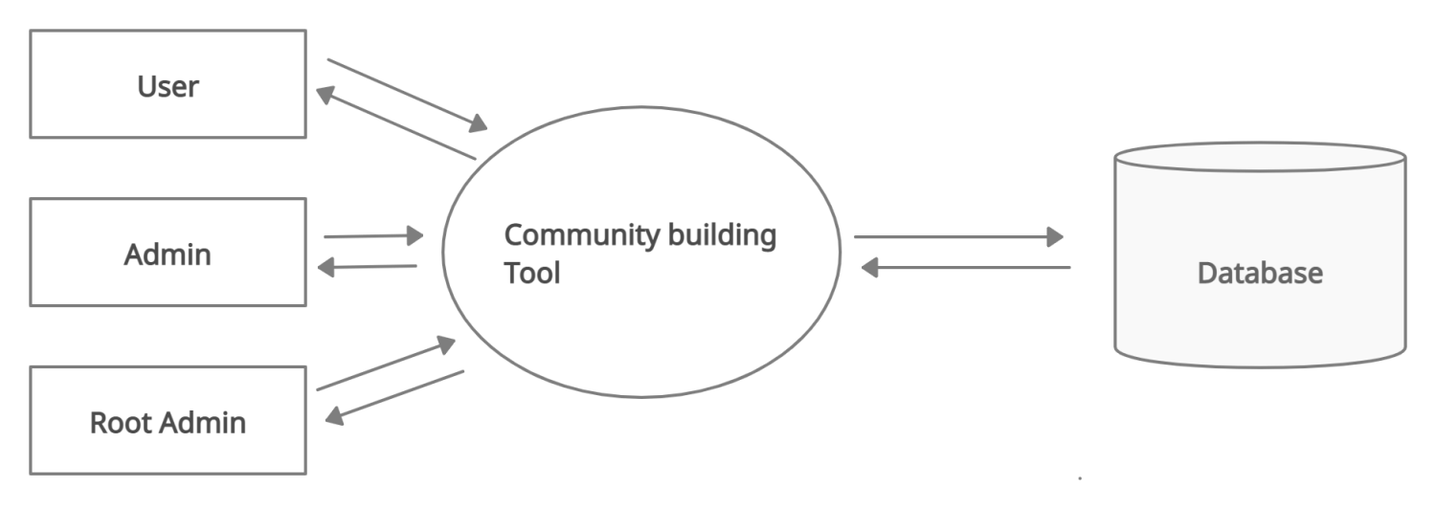

Level 1

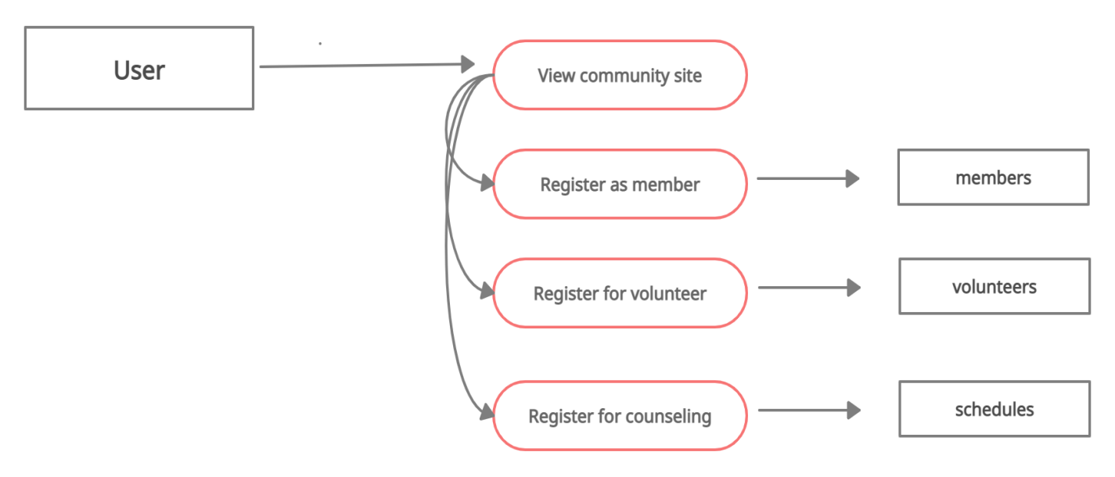

Level 2

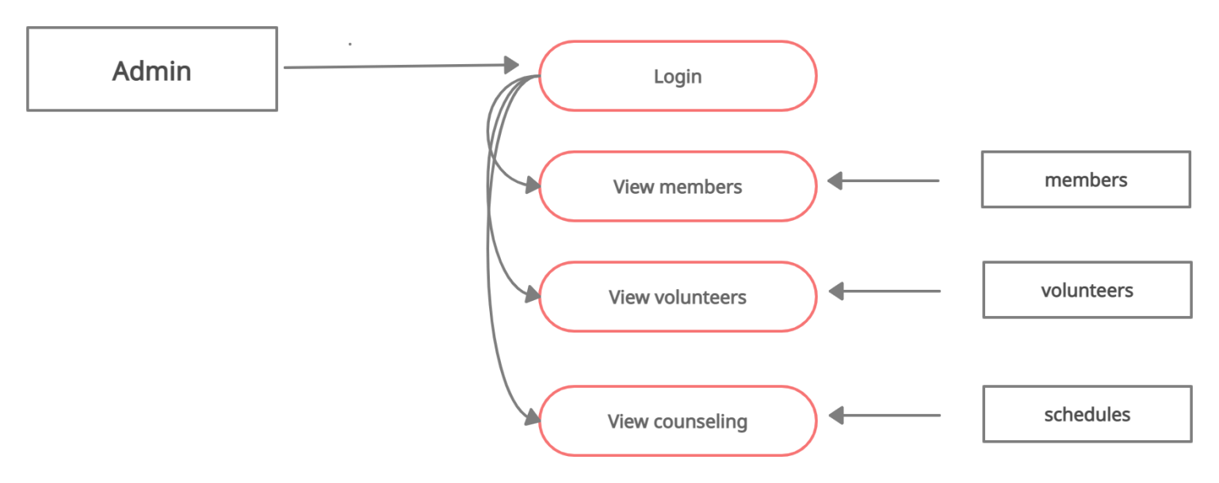

Level 3

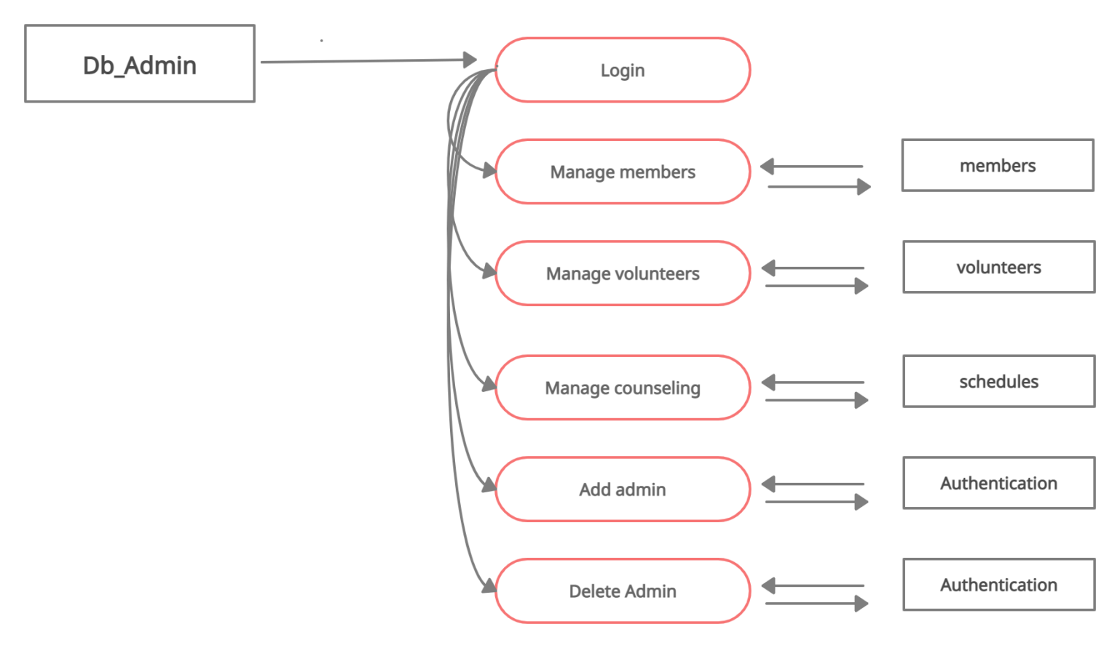

LIST OF ENTITIES AND ATTRIBUTES

Entity Relationship Diagram Notations

Entity:

An entity is an object or concept about which you want to store information.

Entity

Attribute:

Each entity has attributes, or particular properties that describe the entity.



Key attribute :

A key attribute is the unique, distinguishing characteristic of the entity.

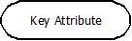

Relationships:

Relationships illustrate how two entities share information in the database structure.
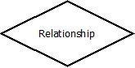

The ER diagram used in this project is given below:

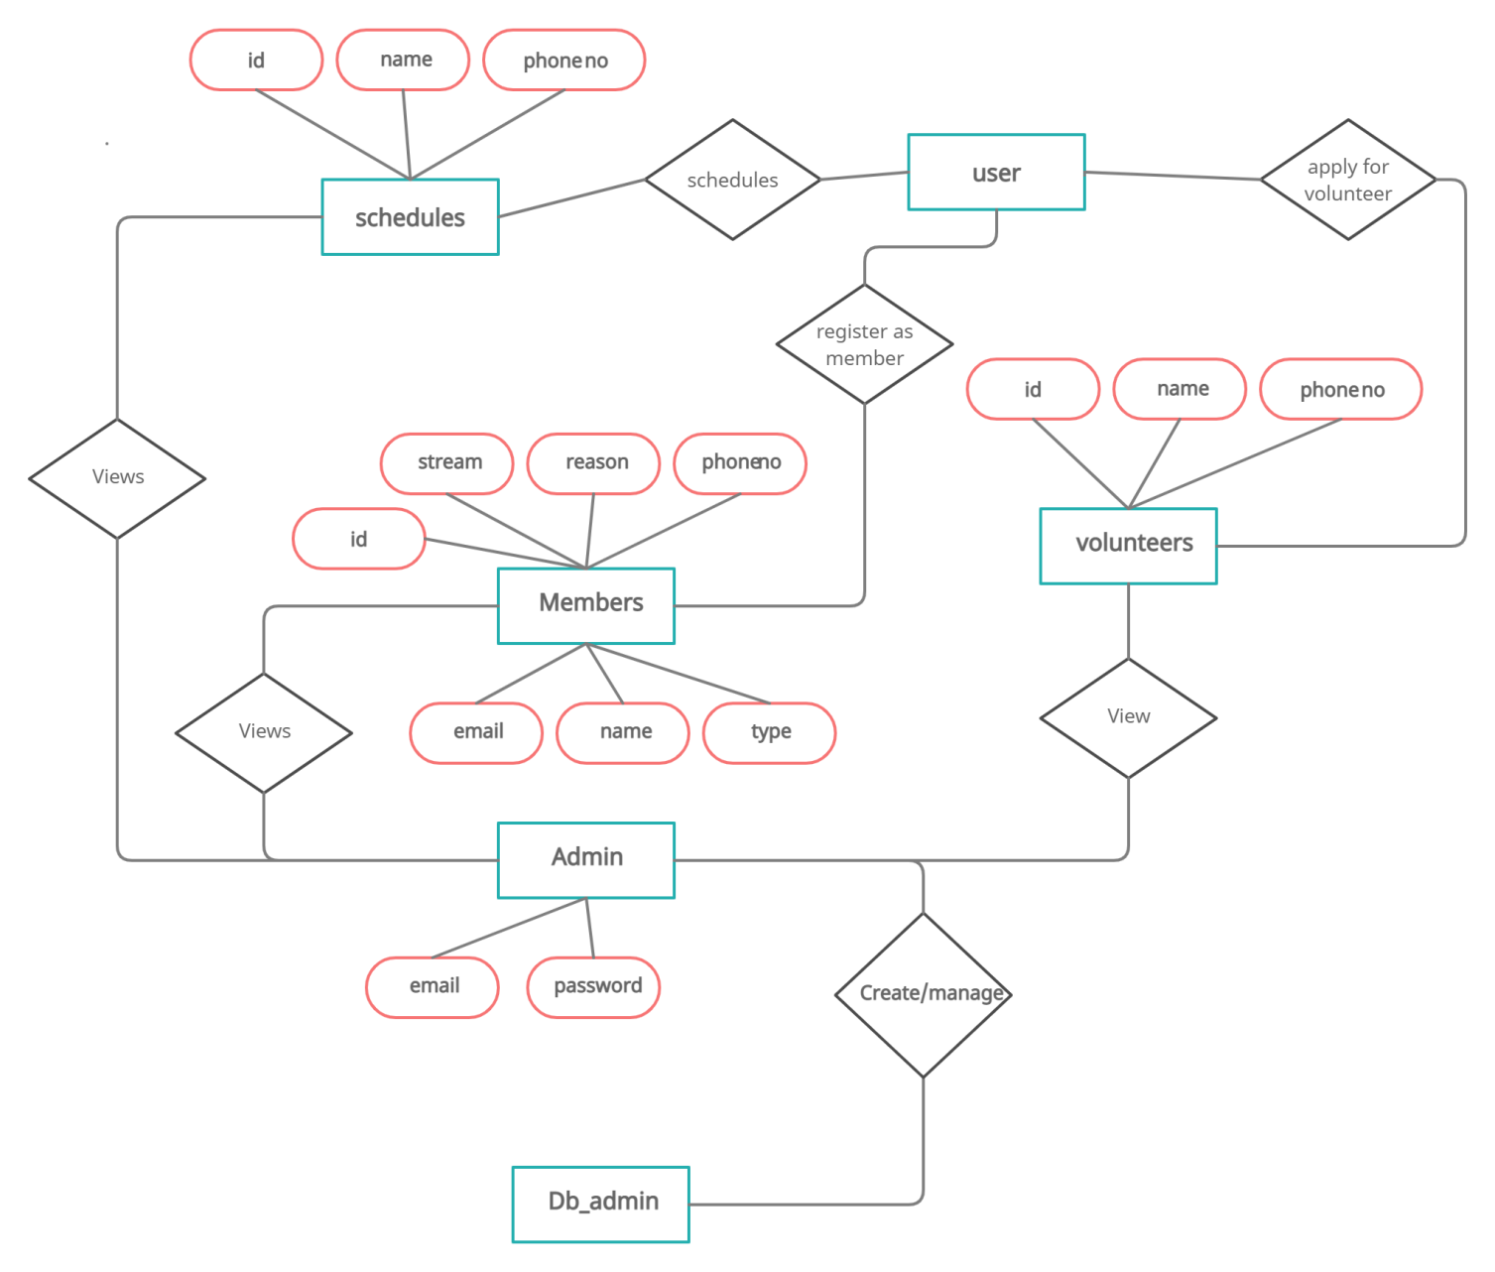

DatabaseDesign
Database design is the process of producing a detailed data model of a database. This logical data model contains all the needed logical and physical design choices and physical storage parameters needed to generate a design in a data definition language, which can then be used to create a database. The term database design can be used to describe many different parts of the design of an overall database system. Principally, and most correctly, it can be thought of as the logical design of the base data structures used to store the data. Inthe relational model these are the tables and views. In an object database the entities and relationships map directly to object classes and named relationships. However, the term database design could also be used to apply to the overall process of designing, not just the base data structures, but also the forms and queries used as part of the overall database application within the database management system.The process of doing database design generally consists of a number of steps which will be carried out by the database designer.

Usually, the designer must:

- Determine the relationships between the different dataelements.
- Superimpose a logical structure upon the data on the basis of theserelationships

Normalization
Normalization is the process of decomposing a set of relations with anomalies to produce smaller and well-structured relations that contain minimum redundancy. It is a formal process of deciding which attributes should be grouped together in a relation.
First Normal Form: First normal form does not allow multi valued and composite valued attributes. It states that the domain of an attribute must include only atomic values and that value of any attribute in a tuple must be single value from the domain of that attribute.
Second Normal Form: In second normal form, for relations where primary key constrains multiple attributes, non-key attributes should not be functionally dependent on a part of the primarykey.
Third Normal Form: In third normal form it satisfies the second normal form and no non-key attributes of relation transitively dependent on primary key.

STRUCTURE OF TABLES
Member

Column Name | Data Type
id | Int(11)
email | Varchar(25)
name | Varchar(20)
nick_name | Varchar(20)
Phone_number | Int(10)
reason | Varchar(100)
stream | Int(2)
type | Int(2)

Volunteer

Column Name | Data Type
id | Int(11)
name | Varchar(20)
Phone_number | Int(10)
Schedules

Column Name | Data Type
id | Int(11)
name | Varchar(20)
Phone_number | Int(10)

SYSTEM DEVELOPMENT

4.SYSTEMDEVELOPMENT

About the FrontEnd
An Integrated Development Environment (IDE) (also known as Integrated Design Environment or Integrated Debugging Environment) is a software application that provides comprehensive facilities to computer programmers for software development. An IDE normally consists of:
  - A source codeeditor
  - A compiler and/or aninterpreter
  - Build automation tools
  - A debugger

Next js

Next.js is a React framework for developing single page Javascript applications. The benefits of this framework are numerous, both for our clients’ applications as well as for our development team. The more we, as users, interact digitally, the more impatient we become as our expectations are not met by websites and apps that fail to load within milliseconds. Technology decisions play a large part in being able to deliver highly performant, scalable, successful applications and as such, we have started using Next.js for a number of reasons, for the most part related to speed and performance.

Jsx

JSX is an XML/HTML-like syntax used by React that extends ECMAScript so that XML/HTML-like text can co-exist with JavaScript/React code. The syntax is intended to be used by preprocessors (i.e., transpilers like Babel) to transform HTML-like text found in JavaScript files into standard JavaScript objects that a JavaScript engine will parse.

Tailwind Css

Tailwind CSS is self-described as a utility first CSS framework. Rather than focusing on the functionality of the item being styled, Tailwind is centered around how it should be displayed. This makes it easier for the developer to test out new styles and change the layout.

Redux

Redux is a predictable state container designed to help you write JavaScript apps that behave consistently across client, server, and native environments and are easy to test.With Redux, the state of your application is kept in a store, and each component can access any state that it needs from this store.

About the Back-End

Servers

A database server is used to store data in a database. Users can access the data and manipulate it. There are many types of databases. The most popular among them is the Relational Database Management System (RDBMS).

Supabase

Supabase is an open source Firebase alternative. A service to:
- Listen to database changes.
- Query your tables, including filtering, pagination, and deeply nested relationships (like GraphQL).
- Create, update, and delete rows.
- Manage your users and their permissions.
- Interact with your database using a simple UI.
PostgreSQL

PostgreSQL is a powerful, open source object-relational database system that uses and extends the SQL language combined with many features that safely store and scale the most complicated data workloads. The origins of PostgreSQL date back to 1986 as part of the POSTGRES project at the University of California at Berkeley and has more than 30 years of active development on the core platform.

Firebase

Google Firebase is a Google-backed application development software that enables developers to develop iOS, Android and Web apps. Firebase provides tools for tracking analytics, reporting and fixing app crashes, creating marketing and product experiment.

SYSTEM TESTING

5.TESTING
Software testing is an investigation conducted to provide stakeholders with information about the quality of the product or service under test. Software testing can also provide an objective, independent view of the software to allow the business to appreciate and understand the risks of software implementation. Test techniques include, but are not limited to, the process of executing a program or application with the intent of finding software bugs (errors or other defects).
Software testing can be stated as the process of validating and verifying that a software program/application/product:
  - meets the requirements that guided its design anddevelopment;
  - works as expected; and
  - Can be implemented with the samecharacteristics.
Software testing, depending on the testing method employed, can be implemented at any time in the development process. However, most of the test effort occurs after the requirements have been defined and the coding process has been completed. As such, the methodology of the test is governed by the software development methodology adopted.
Different software development models will focus the test effort at different points in the development process. Newer development models, such as Agile, often employ test driven development and place an increased portion of the testing in the hands of the developer, before it reaches a formal team of testers. In a more traditional model, most of the test execution occurs after the requirements have been defined and the coding process has been completed.
Testing can never completely identify all the defects within software. Instead, it furnishes a criticism or comparison that compares the state and behavior of the product against oracles—principles or mechanisms by which someone might recognize a problem. These oracles may include (but are not limited to) specifications, contracts, comparable products, past versions of the same product, inferences about intended or expected purpose, user or customer expectations, relevant standards, applicable laws, or other criteria.
Every software product has a target audience. For example, the audience for video game software is completely different from banking software. Therefore, when an organization develops or otherwise invests in a software product, it can assess whether the software product will be acceptable to its end users, its target audience, its purchasers, and other stakeholders. Software testing is the process of attempting to make this assessment.

5.1 Types of Testing

Unit Testing
Unit testing is a test of a simple piece of code – in our case a subroutine, a function, an event. In formal terms it is the smallest piece of code testable. It is the testing of each module and the integration of the overall system is done. Unit testing becomes verification, an effort on the smallest unit of software in the module. This is known as “Module testing”. Component-level testing is the next level up from unit testing. A component can have fairly straight forward functionality, but it is just complex enough to warrant breaking down the actual implementation into several smaller units. In this mode of testing each and every input and output form was been tested in order to check whether they could run successfully. The software worked as expected and no bug had blocked the execution of the test. Distinct outputs were generated for each input. Incorrect output was easily identified. Internal errors were automatically detected through self testing mechanism.

Integration Testing
Integration testing is a systematic testing that can be done with sample data. The need for the integration test is to find the overall system performance. The process of combining multiple modules systematically for conducting tests in order to find errors in the interface between modules is called ‘integration testing’. Integration testing is done after successful completion of unit testing.
The major form in this project is the registration of a third party to the site where he/she can add properties as well as edit the properties. Only the registered third parties can logon to the site, ie every registered third party’s are given a user id and password for login. If the provided user id and password by the third party is correct they can logon to their page where they can add the properties as well as edit their properties.

Validation Testing
Validation testing can be defined as many, but a single definition is that validation succeeds when the software functions in a manner that can be reasonable excepted by the customer. After validation test have been conducted one of the two possible conditions exists.
The function or performance characteristics are acceptable and confirmed to specification. A decision from specification is uncovered and defining list is created. System validation checks the quality of software in both simulated and live environment. First the software goes through a phase in which errors and failures based on simulated user requirementsare verified and studied. All the validations of this project are workingsuccessfully.

User Acceptance Testing
User acceptance of a system is the key factor for the success of any system. The system under consideration was tested for user acceptance by constantly keeping in touch with required. After the developers complete the system testing successfully user acceptance testing is done at the customer end. It is the customer or the end user who knows the designs of the test cases. In this type of testing emphasis is on the usability of the product. Acceptance testing is supported through alpha and beta testing.
Alpha testing is done when the software is made operational for the first time to be tested by the users at developer’s site. Hence it is possible that it will involve making lot of changes to program code. Beta testing follows alpha testing but now the testing is done at the customer’s site that validates the product after using it for few days. At this stage few changes as compared to alpha testing would be made to the product.Here a third party was allowed to run this project. He could run this project by himself without any help from others, because the graphical user interface of this project was very much user friendly.

Black Box Testing
Although tests are designed to uncover errors, they are also used to demonstrate that the software functions are operational, input is properly accepted and output is correctly produced and that the integrity of external information is maintained. A black box test examines some of fundamental aspects of a system with little regard for the internal logical structure of the software.
All input screens were thoroughly tested for data validity and smoothness of data entry operations. Test cases were so formulated to verify whether the system works properly in rare conditions also. Error conditions were checked. Data entry operations are to be user friendly and smooth. Care was taken to make data entry as smooth as possible. Flow of object was made convenient to the data entry operations.

White Box Testing
It is a test case design method that uses the control structure of the procedural design to drive test cases. Using white box testing methods it was guaranteed that most of the independent paths within modules had been exercised at least once, all logical decision on their true and false sides, executed all loops at their boundaries and exercised internal data structures to ensure their data validity. All codes in my project were successfully checked for errors and ensured that there were no errors.

SYSTEM IMPLEMENTATION

6. IMPLEMENTATION
Implementation of the system refers to the final installing of the package in its real environment , to the satisfaction of the indeed users and the operation of the system. It is the process of converting a new or revised system design to operation. It is the key stage in achieving successful new system. The process of putting the developed system in actual use is called system implementation. This includes all those activities that take place to convert from the old system to new system. It must therefore be carefully planned and controlled. Proper guidance should be imparted to the users so that he is comfortable in using the application.

Implementation Plan
The transformation from theoretical designs to working system is done in this stage. Developed package of system is tested with simple data, accurate error identification and then through proposed change from the user etc. a dress rehearsal working of system is done, so as the system is scrutinized, for pointing out errors and modifications required if any keeping in mind the expectations and specifications from the system.

Education AndTraining
The expectations from the system are made achieved by the people who will be involved to be confident of their role in the new system. The complexity of the system is directly proportional to the amount of training and education given for the user .Education isdifferentfromthetraining,astheuserthrougheducationcanbeapartofdevelopmentof the system. Education has the capability to make training more interesting and important contributions in the systemchanges.
Training just means to give user specific skills in order to meet their new job requirements. The role of system analyst in training will make it more understandable and effective. Training provides a better overview of new system and its present objectives.

Training of Application Software
Awareness about the new system is made to the users through training, and with the underlying philosophy of the system (screen design, flow, error types during inputs, validation checks etc.) application use the system, as the users of the system may be of at different levels of hierarchy.
Post Implementation Review
System performance v/s expected requirements are evaluated. The implementation problems if any is taken seriously and taken care of along with admiring the achievements, failures etc. The works done here are used to improve the efficiency and user friendliness of the system.
Security
System security is a branch of technology known as information security as applied to computers and networks. The objective of system security includes protection of information and property from theft, corruption, or natural disaster, while allowing the information and property to remain accessible and productive to its intended users. The term system security, means the collective processes and mechanisms by which sensitive and valuable information and services are protected from publication, tempering or collapse by unauthorized activities or untrustworthy individuals and unplanned events respectively. The technologies of system security are based on logic. As security is not necessarily the primary goal of most computer applications, designing a program with security in mind often imposes restrictions on that program’s behavior.

SYSTEM MAINTENANCE

7.Maintenance

Maintenance is making adaptation of the software for external changes (requirements changes or enhancements) and internal changes (fixing bugs). When changes are made during the maintenance phase all preceding steps of the model must be revisited.

There are three types of maintenance:

• Corrective(Fixing bugs/errors)
• Adaptive(Updates due to environment changes)
• Perfective(Enhancements, requirements changes

Maintenance is enigma of the system development. The definition of the software maintenance can be given describing four activities that are undertaken after the program is released for use.

The maintenance activity occurs since it is unreasonable to assume that software testing will uncover all in a large system. The second activity that contributes the definition of maintenance occurs since rapid changes are encountered in every aspects of computing.

The third activity involves recommendation for new capabilities, modification to the existing functions and general enhancements when the software is used. The fourth maintenance activity occurs when software is changed to improve future maintainability or reliability.

SCREENSHOTS

8.SCREENSHOTS

SCREENSHOT WEBSITE

User

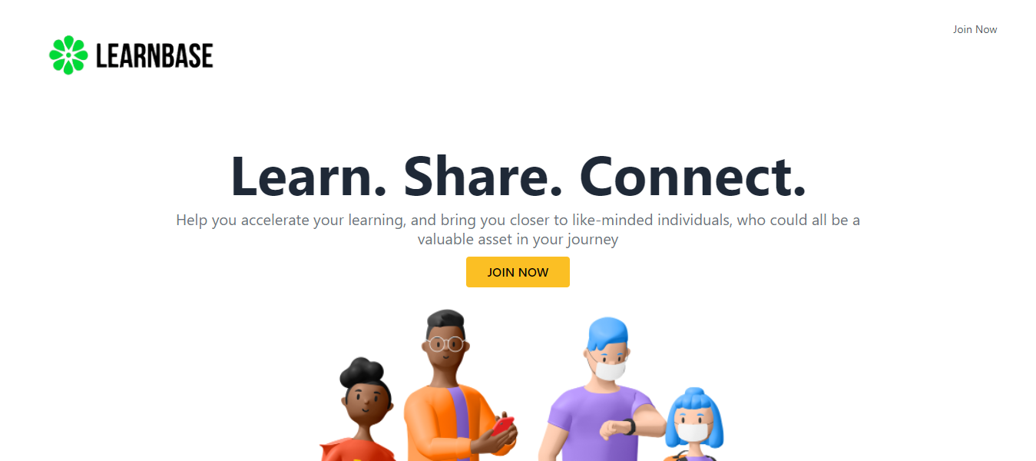

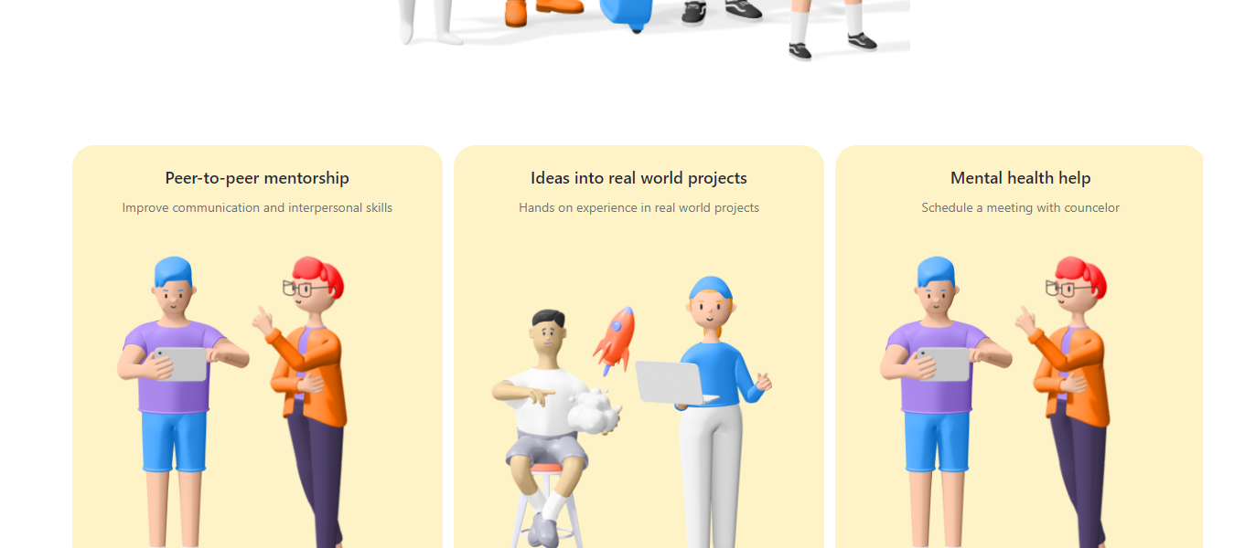
Member Registration

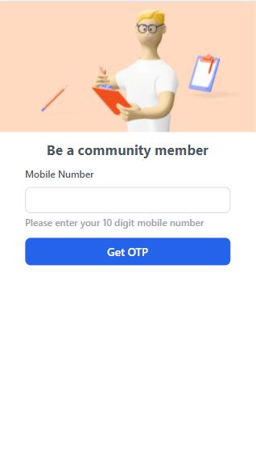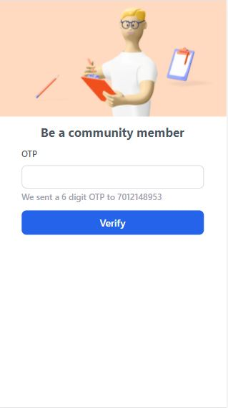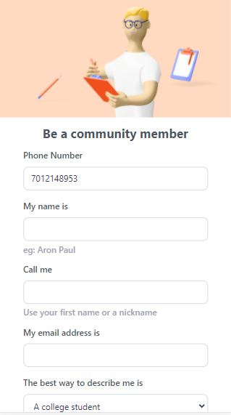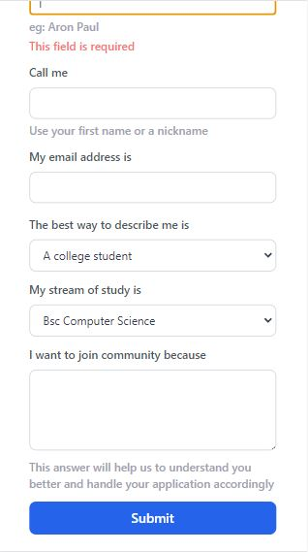

Register as volunteer

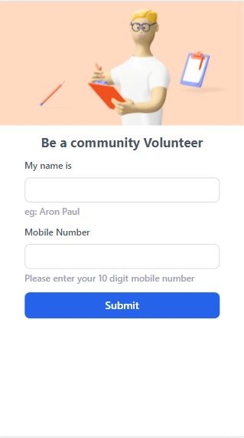

Schedule for counseling

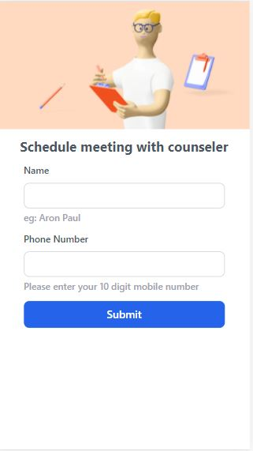

Admin
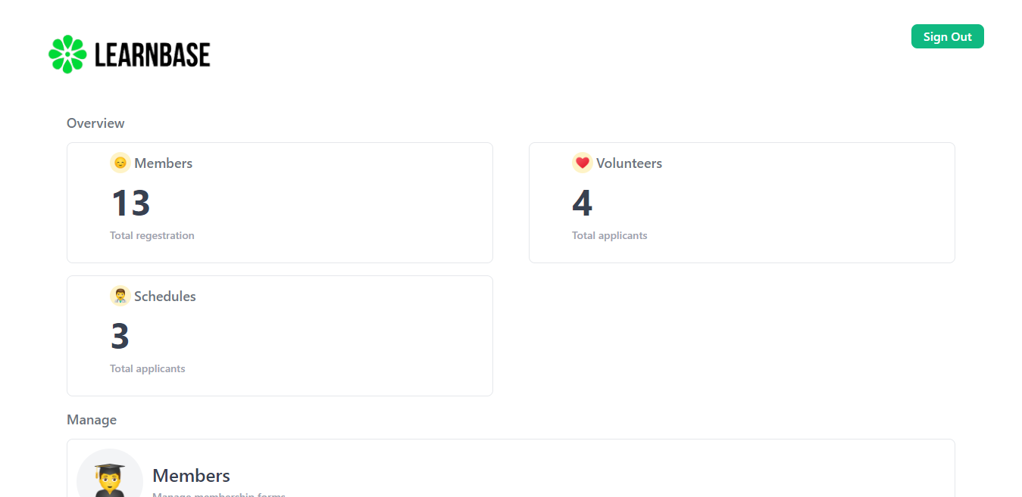

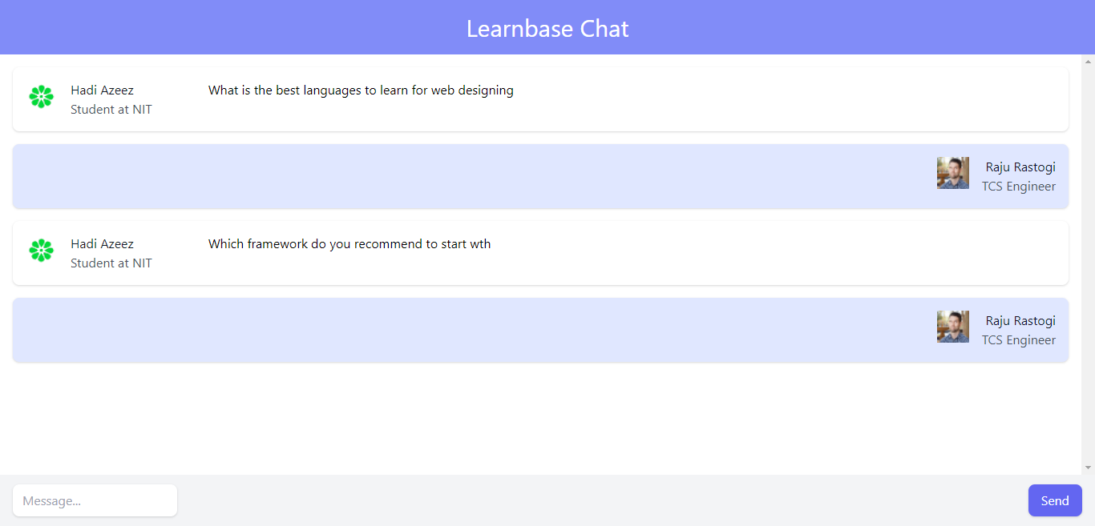
Chatroom

Db Admin

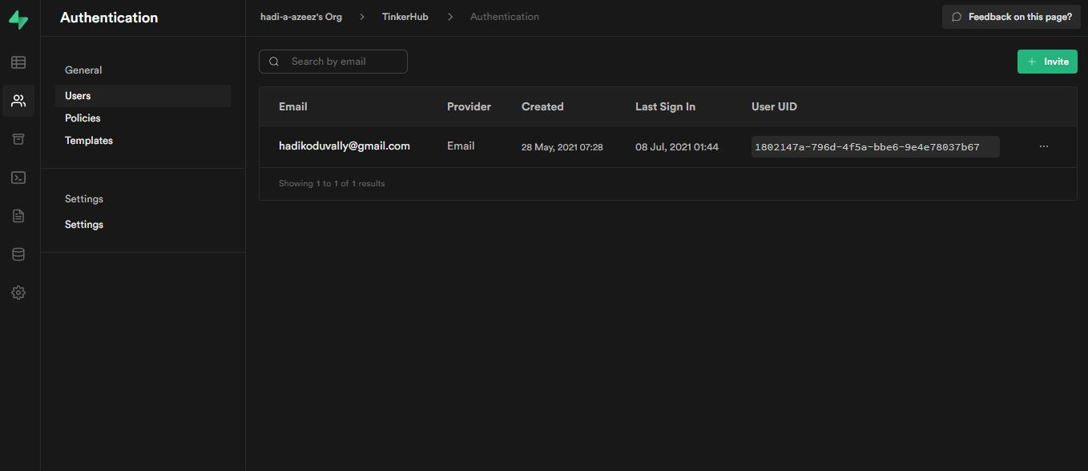

THANK YOU

